Mobility Support in IPv6
Charles E. Perkins and David B. Johnson
Proceedings of the Second Annual International Conference on Mobile Computing and Networking(MobiCom’96), November 10-12, 1996
Abstract
We have designed protocol enhancements for IPv6, know as Mobile IPv6, that allow transparent routing of IPv6 packets to mobile nodes, taking advantage of the opportunities made possible by the design of a new version of IP.
- Introduction
To avoid the triangle routing.

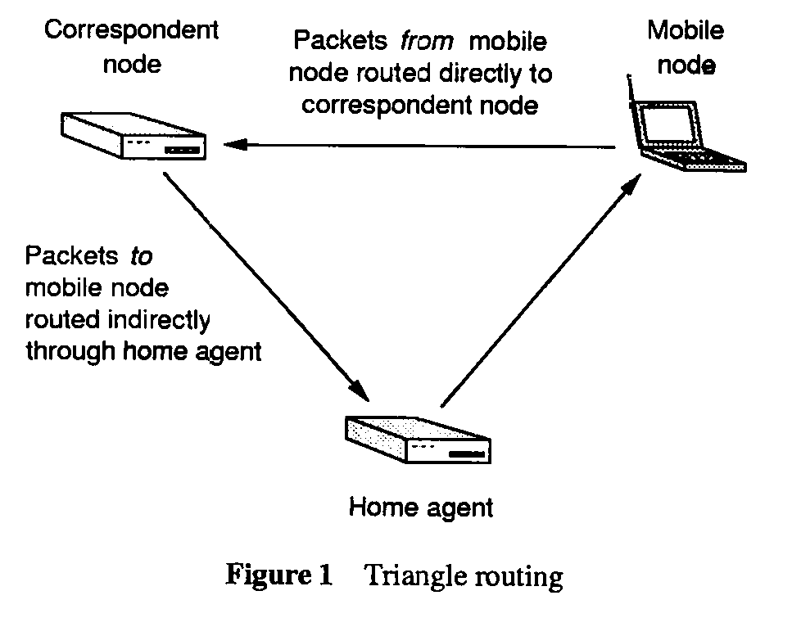
2. Overview of IPv6
The defined IPv6 extension headers include:
Destination Options header, Hop-by-Hop Option header, a Routing header, and an Authentication header.
3. Overview of Mobile IPv6
When sending a packet to any IPv6 destination, a node checks its Binding Cache for an entry for the packet’s destination address, and if a cached binding for this address is found, the node routes the packet directly to the mobile node at the care-of address indicated in this binding using an IPv6 Routing header; If no Binding Cache entry is found, the node instead sends the packet normally, and the packet is then intercepted and tunneled by the mobile node’s home agent using an IPv6 encapsulation.
4. The Binding Update Option

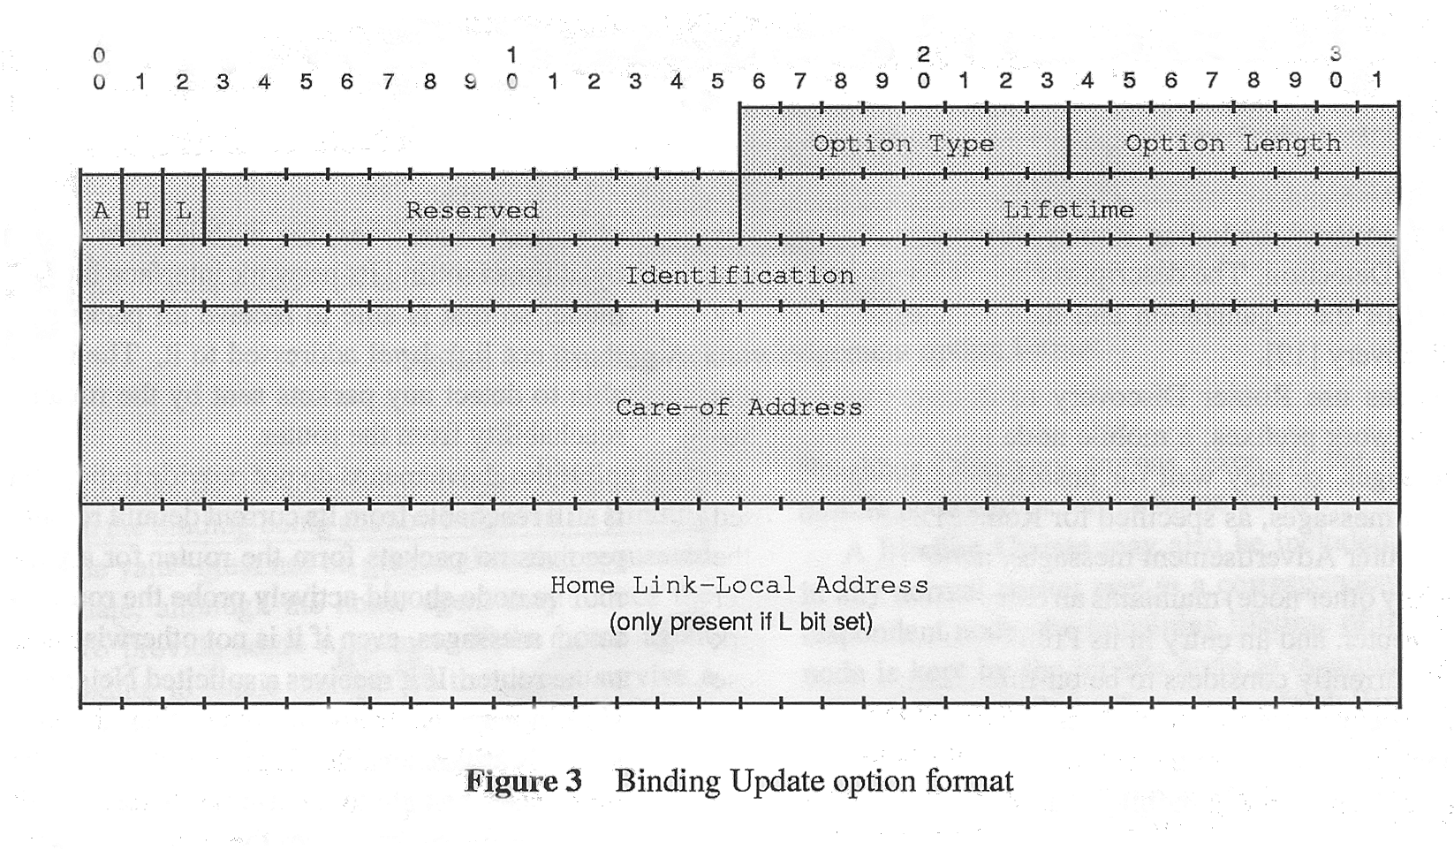
5. The Binding Acknowledgement Option

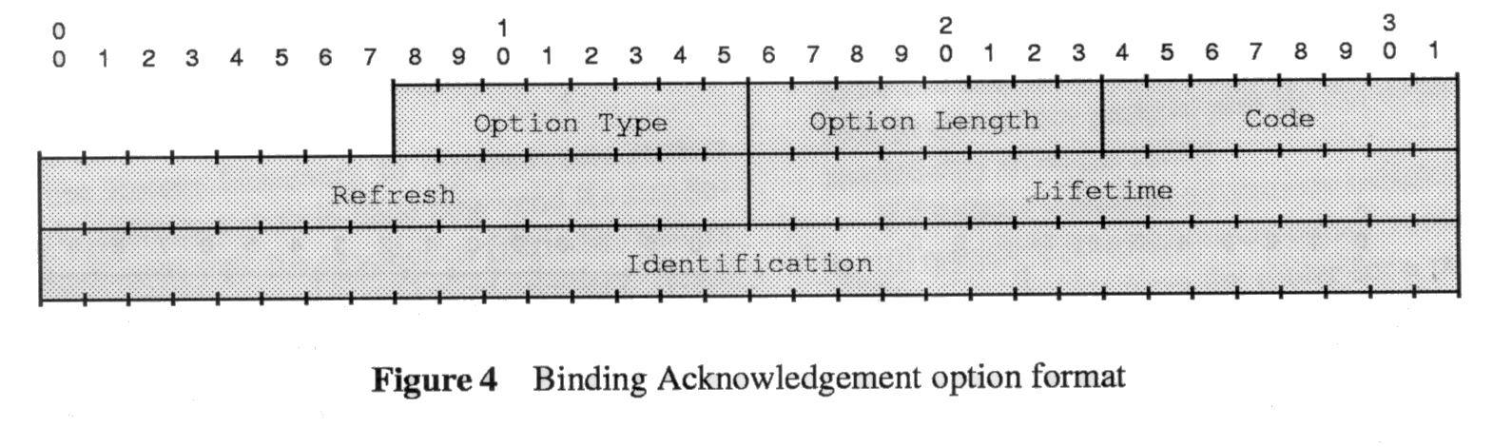
6. Conclusion
Created by : Shin-Si Chen
Date : Sept 18 ,1998

